Zenil Shah

Roll no: 44

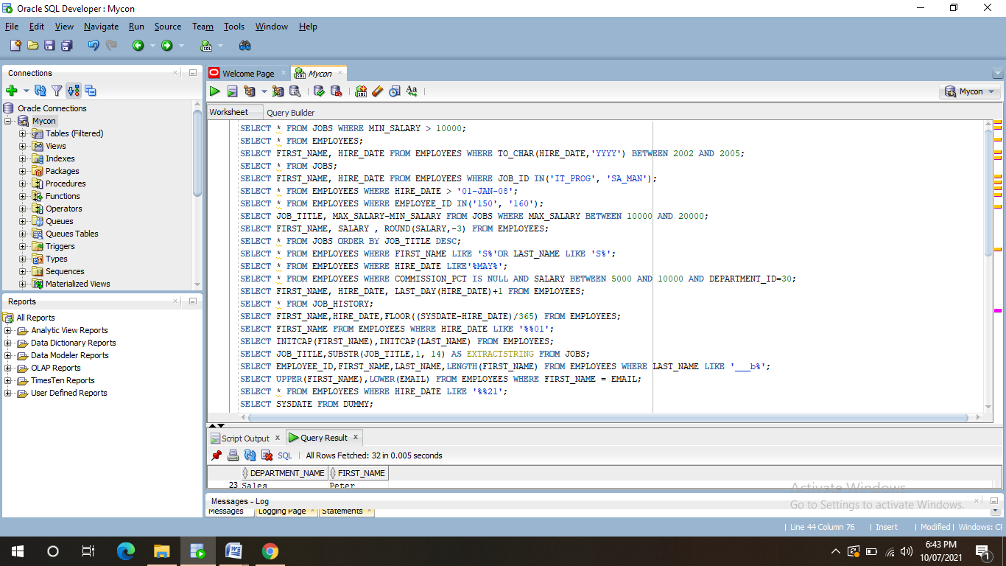

1.SELECT * FROM JOBS WHERE MIN_SALARY > 10000;

SELECT * FROM EMPLOYEES;

2. SELECT FIRST_NAME, HIRE_DATE FROM EMPLOYEES WHERE TO_CHAR(HIRE_DATE,'YYYY') BETWEEN 2002 AND 2005;

SELECT * FROM JOBS;

3.SELECT FIRST_NAME, HIRE_DATE FROM EMPLOYEES WHERE JOB_ID IN('IT_PROG', 'SA_MAN');

4.SELECT * FROM EMPLOYEES WHERE HIRE_DATE > '01-JAN-08';

5.SELECT * FROM EMPLOYEES WHERE EMPLOYEE_ID IN('150', '160');

6. SELECT FIRST_NAME, SALARY, COMMISSION_PCT, HIRE_DATE FROM EMPLOYEES WHERE SALARY <10000;

7.SELECT JOB_TITLE, MAX_SALARY-MIN_SALARY FROM JOBS WHERE MAX_SALARY BETWEEN 10000 AND 20000;

8.SELECT FIRST_NAME, SALARY , ROUND(SALARY,-3) FROM EMPLOYEES;

9.SELECT * FROM JOBS ORDER BY JOB_TITLE DESC;

10.SELECT * FROM EMPLOYEES WHERE FIRST_NAME LIKE 'S%'OR LAST_NAME LIKE 'S%';

11.SELECT * FROM EMPLOYEES WHERE HIRE_DATE LIKE'%MAY%';

12.SELECT * FROM EMPLOYEES WHERE COMMISSION_PCT IS NULL AND SALARY BETWEEN 5000 AND 10000 AND DEPARTMENT_ID=30;

13.SELECT FIRST_NAME, HIRE_DATE, LAST_DAY(HIRE_DATE)+1 FROM EMPLOYEES;

SELECT * FROM JOB_HISTORY;

14.SELECT FIRST_NAME,HIRE_DATE,FLOOR((SYSDATE-HIRE_DATE)/365) FROM EMPLOYEES;

15.SELECT FIRST_NAME FROM EMPLOYEES WHERE HIRE_DATE LIKE '%%01';

16.SELECT INITCAP(FIRST_NAME),INITCAP(LAST_NAME) FROM EMPLOYEES;

17.(DOUBT)SELECT JOB_TITLE,SUBSTR(JOB_TITLE,1, 14) AS EXTRACTSTRING FROM JOBS;

18.SELECT EMPLOYEE_ID,FIRST_NAME,LAST_NAME,LENGTH(FIRST_NAME) FROM EMPLOYEES WHERE LAST_NAME LIKE '___b%';

19.SELECT UPPER(FIRST_NAME),LOWER(EMAIL) FROM EMPLOYEES WHERE FIRST_NAME = EMAIL;

20.SELECT * FROM EMPLOYEES WHERE HIRE_DATE LIKE '%%21';

SELECT SYSDATE FROM DUMMY;

21.SELECT SYSDATE - TO_DATE('01-JAN-2011') FROM DUMMY;

22.SELECT TO_CHAR(HIRE_DATE, 'MM'),COUNT(*) FROM EMPLOYEES WHERE TO_CHAR(HIRE_DATE,'YYYY')=TO_CHAR(SYSDATE,'YYYY') GROUP BY TO_CHAR(HIRE_DATE,'MM');

23.SELECT MANAGER_ID, COUNT(*) FROM EMPLOYEES GROUP BY MANAGER_ID;

24.SELECT EMPLOYEE_ID, MAX(END_DATE) FROM JOB_HISTORY GROUP BY EMPLOYEE_ID;

25.SELECT COUNT(*) FROM EMPLOYEES WHERE TO_CHAR(HIRE_DATE,'DD')>15;

26.SELECT COUNTRY_ID, COUNT(*) FROM LOCATIONS GROUP BY COUNTRY_ID;

27.SELECT DEPARTMENT_ID,AVG(SALARY) FROM EMPLOYEES WHERE COMMISSION_PCT IS NOT NULL GROUP BY DEPARTMENT_ID;

28.SELECT JOB_ID, COUNT(*), SUM(SALARY),MAX(SALARY)-MIN(SALARY) FROM EMPLOYEES GROUP BY JOB_ID;

29.SELECT JOB_ID , AVG(SALARY) FROM EMPLOYEES HAVING AVG(SALARY)>10000 GROUP BY JOB_ID;

30.SELECT TO_CHAR(HIRE_DATE, 'YYYY')FROM EMPLOYEES GROUP BY TO_CHAR(HIRE_DATE, 'YYYY') HAVING COUNT(EMPLOYEE_ID) > 10;

31.SELECT DEPARTMENT_ID FROM EMPLOYEES WHERE COMMISSION_PCT IS NOT NULL GROUP BY DEPARTMENT_ID HAVING COUNT(COMMISSION_PCT)>5;

32.SELECT EMPLOYEE_ID FROM JOB_HISTORY GROUP BY EMPLOYEE_ID HAVING COUNT(*)>1;

33.SELECT JOB_ID FROM JOB_HISTORY WHERE END_DATE - START_DATE >100 GROUP BY JOB_ID HAVING COUNT(*)>3;

34.SELECT DEPARTMENT_ID, TO_CHAR(HIRE_DATE,'YYYY'),COUNT(EMPLOYEE_ID) FROM EMPLOYEES GROUP BY DEPARTMENT_ID,TO_CHAR(HIRE_DATE,'YYYY');

35.SELECT DEPARTMENT_ID FROM EMPLOYEES GROUP BY DEPARTMENT_ID HAVING COUNT(EMPLOYEE_ID)> 5;

36. UPDATE EMPLOYEES SET SALARY = 8000 WHERE EMPLOYEE_ID = 115 AND SALARY < 6000

38.DELETE FROM DEPARTMENTS WHERE DEPARTMENT_ID=20

39.UPDATE EMPLOYEES SET JOB_ID= 'IT_PROG'

WHERE EMPLOYEE_ID=110 AND DEPARTMENT_ID=10 AND NOT JOB_ID LIKE 'IT%'

40. INSERT INTO DEPARTMENTS (150,'SPORTS',120,1200)

41.SELECT DEPARTMENT_NAME, COUNT(*) FROM EMPLOYEES NATURAL JOIN DEPARTMENTS GROUP BY DEPARTMENT_NAME

42.SELECT EMPLOYEE_ID, JOB_TITLE, END_DATE-START_DATE DAYS

FROM JOB_HISTORY NATURAL JOIN JOBS

WHERE DEPARTMENT_ID=30

.

43.SELECT DEPARTMENT_NAME, FIRST_NAME FROM DEPARTMENTS D JOIN EMPLOYEES E ON (D.MANAGER_ID=E.EMPLOYEE_ID)

44.SELECT DEPARTMENT_NAME, FIRST_NAME, CITY FROM DEPARTMENTS D JOIN EMPLOYEES E ON (D.MANAGER_ID=E.EMPLOYEE_ID) JOIN LOCATIONS L USING (LOCATION_ID)

45.SELECT COUNTRY_NAME, CITY, DEPARTMENT_NAME

FROM COUNTRIES JOIN LOCATIONS USING (COUNTRY_ID)

JOIN DEPARTMENTS USING (LOCATION_ID)

46.SELECT JOB_TITLE, DEPARTMENT_NAME, LAST_NAME, START_DATE

FROM JOB_HISTORY JOIN JOBS USING (JOB_ID) JOIN DEPARTMENTS

USING (DEPARTMENT_ID) JOIN EMPLOYEES USING (EMPLOYEE_ID)

WHERE TO_CHAR(START_DATE,'YYYY') BETWEEN 2000 AND 2005

47.SELECT JOB_TITLE, AVG(SALARY) FROM EMPLOYEES

NATURAL JOIN JOBS GROUP BY JOB_TITLE

48.SELECT JOB_TITLE, FIRST_NAME, MAX_SALARY-SALARY DIFFERENCE FROM EMPLOYEES NATURAL JOIN JOBS

49.SELECT JOB_TITLE, FIRST_NAME, MAX_SALARY-SALARY DIFFERENCE FROM EMPLOYEES NATURAL JOIN JOBS WHERE DEPARTMENT_ID = 30.

50.SELECT JH.*

FROM JOB_HISTORY JH JOIN EMPLOYEES E ON (JH.EMPLOYEE_ID = E.EMPLOYEE_ID)

WHERE SALARY > 15000

51.SELECT DEPARTMENT_NAME, FIRST_NAME, SALARY

FROM DEPARTMENTS D JOIN EMPLOYEES E ON (D.MANAGER_ID=E.MANAGER_ID)

WHERE (SYSDATE-HIRE_DATE) / 365 > 5

52.SELECT FIRST_NAME FROM EMPLOYEES E1 JOIN EMPLOYEES E2 ON (E1.MANAGER_ID=E2.EMPLOYEE_ID)

WHERE E1.HIRE_DATE < E2.HIRE_DATE

53.SELECT FIRST_NAME, JOB_TITLE FROM EMPLOYEES E JOIN JOB_HISTORY JH ON (JH.EMPLOYEE_ID = E.EMPLOYEE_ID) JOIN JOBS J ON( JH.JOB_ID = J.JOB_ID)

WHERE MONTHS_BETWEEN(END_DATE,START_DATE) < 6

54.SELECT FIRST_NAME, COUNTRY_NAME FROM EMPLOYEES JOIN DEPARTMENTS USING(DEPARTMENT_ID)

JOIN LOCATIONS USING( LOCATION_ID)

JOIN COUNTRIES USING ( COUNTRY_ID)

55.SELECT DEPARTMENT_NAME, AVG(SALARY), COUNT(COMMISSION_PCT)

FROM DEPARTMENTS JOIN EMPLOYEES USING (DEPARTMENT_ID)

GROUP BY DEPARTMENT_NAME

56.SELECT TO_CHAR(HIRE_DATE,'MON-YY')

FROM EMPLOYEES JOIN DEPARTMENTS USING (DEPARTMENT_ID) JOIN LOCATIONS USING (LOCATION_ID)

WHERE CITY = 'Seattle'

GROUP BY TO_CHAR(HIRE_DATE,'MON-YY')

HAVING COUNT(*) > 5

57.SELECT * FROM DEPARTMENTS WHERE DEPARTMENT_ID IN

( SELECT DEPARTMENT_ID FROM EMPLOYEES

GROUP BY DEPARTMENT_ID

HAVING MAX(SALARY)>10000)

.

58.SELECT * FROM DEPARTMENTS WHERE MANAGER_ID IN

(SELECT EMPLOYEE_ID FROM EMPLOYEES WHERE FIRST_NAME='SMITH')

59. SELECT * FROM JOBS WHERE JOB_ID IN

(SELECT JOB_ID FROM EMPLOYEES WHERE TO_CHAR(HIRE_DATE,'YYYY')=TO_CHAR(SYSDATE,'YYYY'))

.

60.SELECT * FROM EMPLOYEES WHERE EMPLOYEE_ID NOT IN

(SELECT EMPLOYEE_ID FROM JOB_HISTORY)

.

61.SELECT JOB_TITLE, AVG(SALARY) FROM JOBS NATURAL JOIN EMPLOYEES

GROUP BY JOB_TITLE

WHERE EMPLOYEE_ID IN

(SELECT EMPLOYEE_ID FROM JOB_HISTORY)

62.SELECT COUNTRY_NAME, CITY, COUNT(DEPARTMENT_ID)

FROM COUNTRIES JOIN LOCATIONS USING (COUNTRY_ID) JOIN DEPARTMENTS USING (LOCATION_ID)

WHERE DEPARTMENT_ID IN

(SELECT DEPARTMENT_ID FROM EMPLOYEES

GROUP BY DEPARTMENT_ID

HAVING COUNT(DEPARTMENT_ID)>5)

GROUP BY COUNTRY_NAME, CITY;

63.SELECT FIRST_NAME FROM EMPLOYEES

WHERE EMPLOYEE_ID IN

(SELECT MANAGER_ID FROM EMPLOYEES

GROUP BY MANAGER_ID

HAVING COUNT(*)>5)

64.SELECT FIRST_NAME, JOB_TITLE, START_DATE, END_DATE

FROM JOB_HISTORY JH JOIN JOBS J USING (JOB_ID) JOIN EMPLOYEES E ON ( JH.EMPLOYEE_ID = E.EMPLOYEE_ID)

WHERE COMMISSION_PCT IS NULL

SELECT * FROM DEPARTMENTS

WHERE DEPARTMENT_ID NOT IN

( SELECT DEPARTMENT_ID FROM EMPLOYEES WHERE FLOOR((SYSDATE-HIRE_DATE)/365) < 2)

SELECT * FROM DEPARTMENTS

WHERE DEPARTMENT_ID IN

(SELECT DEPARTMENT_ID FROM EMPLOYEES

WHERE EMPLOYEE_ID IN (SELECT EMPLOYEE_ID FROM JOB_HISTORY)

GROUP BY DEPARTMENT_ID

HAVING MAX(SALARY) >10000)

SELECT * FROM JOBS

WHERE JOB_ID IN

(SELECT JOB_ID FROM EMPLOYEES WHERE EMPLOYEE_ID IN

(SELECT EMPLOYEE_ID FROM JOB_HISTORY WHERE JOB_ID='IT_PROG'))

SELECT DEPARTMENT_ID,FIRST_NAME, SALARY FROM EMPLOYEES OUTER WHERE SALARY =

(SELECT MAX(SALARY) FROM EMPLOYEES WHERE DEPARTMENT_ID = OUTER.DEPARTMENT_ID)

SELECT CITY FROM LOCATIONS WHERE LOCATION_ID =

(SELECT LOCATION_ID FROM DEPARTMENTS WHERE DEPARTMENT_ID =

(SELECT DEPARTMENT_ID FROM EMPLOYEES WHERE EMPLOYEE_ID=105))